**PROJECT NOTES**

**SIMULATION**

**Open SHS**

This is the field of:

* Internet of Things (IoT),
* machine learning and smart home simulation to test and evaluate their models.

These research projects require either real or synthetic datasets that are representative of the scenarios captured from a smart home. However, the cost to build real smart homes and the collection of datasets for such scenarios is expensive and sometimes infeasible/impractical to many projects.

Moreover, several issues face the researchers before building the smart home such as;

* finding the optimal placement of the sensors
* lack of flexibility
* finding appropriate 30 participants
* privacy and ethical issues.

There’s a need to add more sensors or to control the type of the generated scenarios. Very few of such datasets record the readings of the sensors in real-time and provide a detailed time-stamped field (e.g. ARAS [activity recog] dataset.

**challenges facing the preparation of real datasets.**

1. having a robust and continuous capturing mechanism for the sensors’ data.
2. following an appropriate annotation method for the inhabitants’ activities
3. A real testbed. **(b)** A simulated testbed.

MC- TRAINING & TESTING EVAL – redesign (ADD/REMOVE dev)

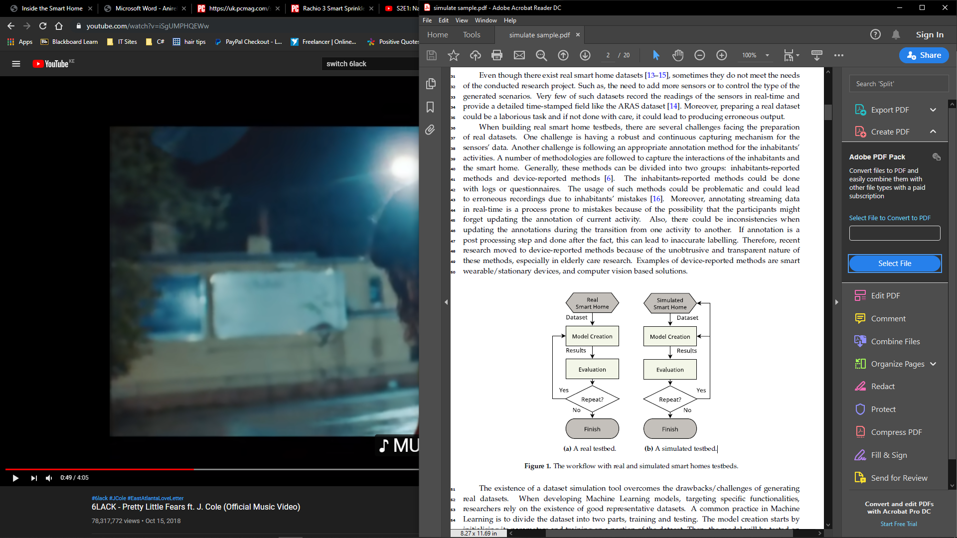

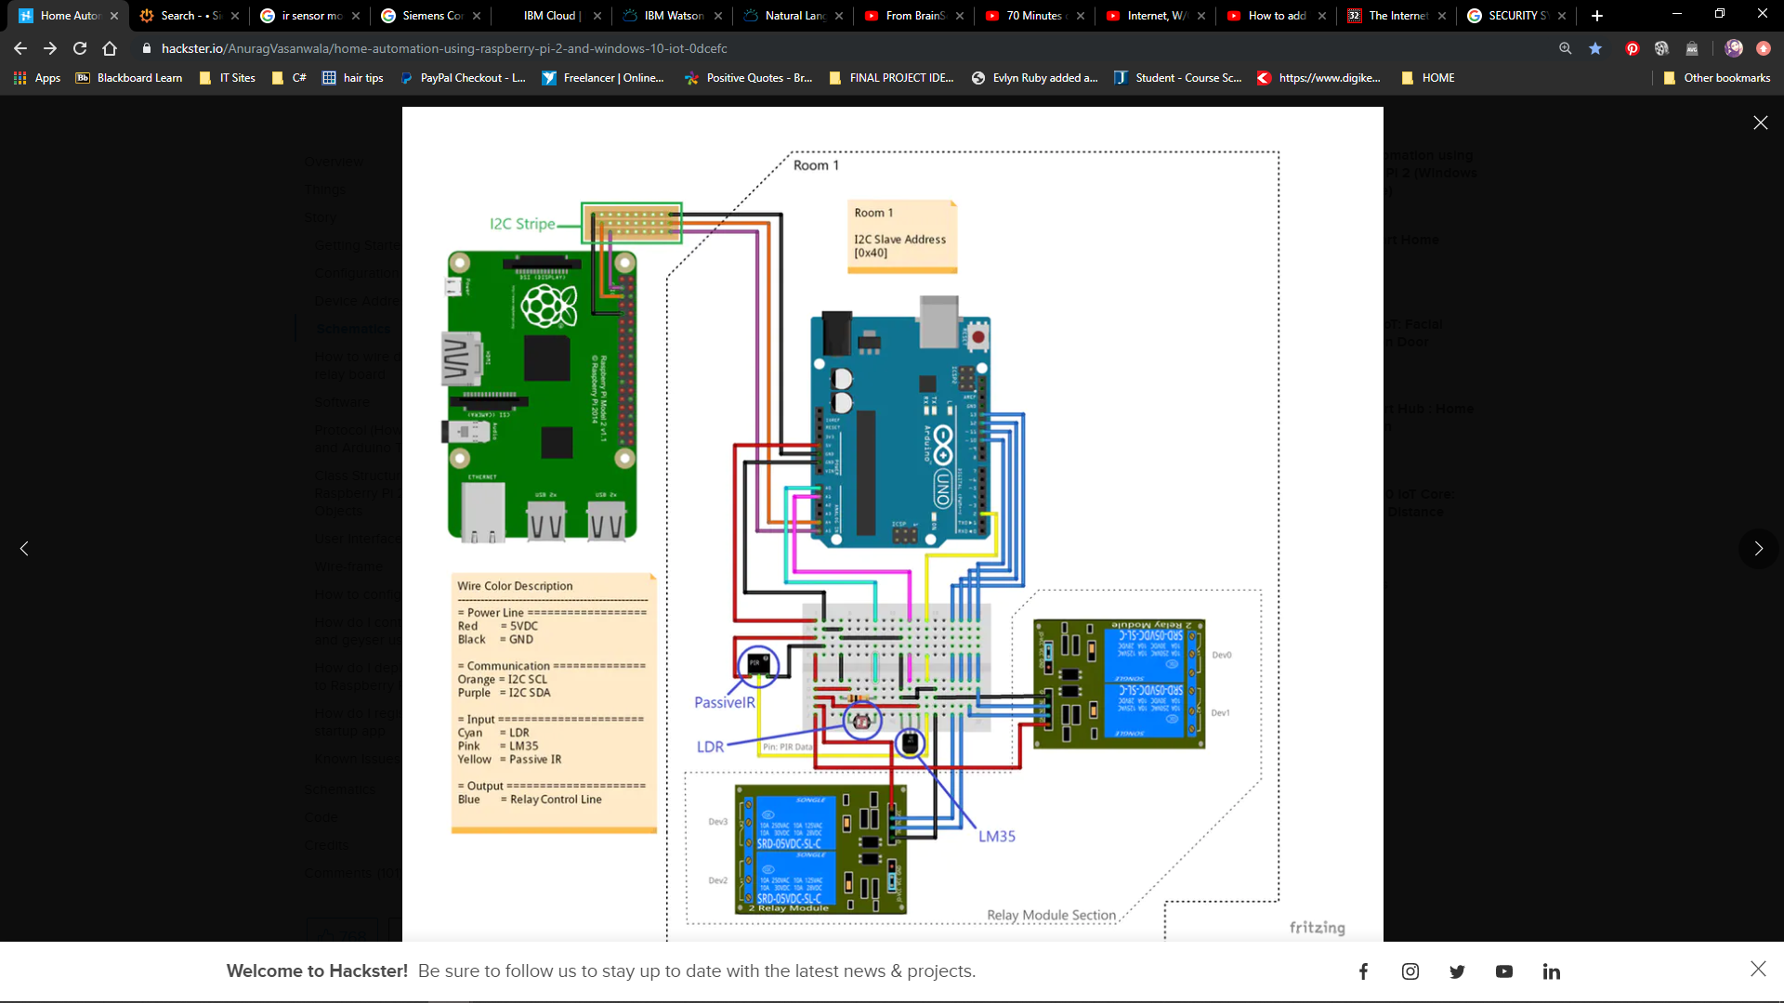

[**smart home security system**](https://uk.pcmag.com/home-security/74995/the-best-smart-home-security-systems) connects to your Wi-Fi network so you can monitor and control your devices using your smartphone and an app. Entry-level systems usually include:

* some door and window sensors
* a motion detector
* and a hub that communicates with these devices using one or more wireless protocols (Wi-Fi, Z-Wave, Zigbee, or a proprietary mesh network).

You can add extra door, motion, and window sensors to provide coverage for your entire house and build a comprehensive system that includes:

* door locks
* garage door openers
* [**indoor**](https://uk.pcmag.com/home-security-cameras/39333/the-best-indoor-home-security-cameras) and outdoor surveillance cameras
* Lights
* Sirens
* smoke/CO detectors
* water sensors etc

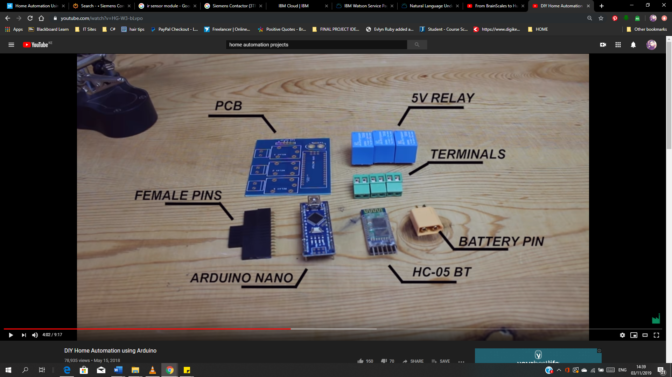

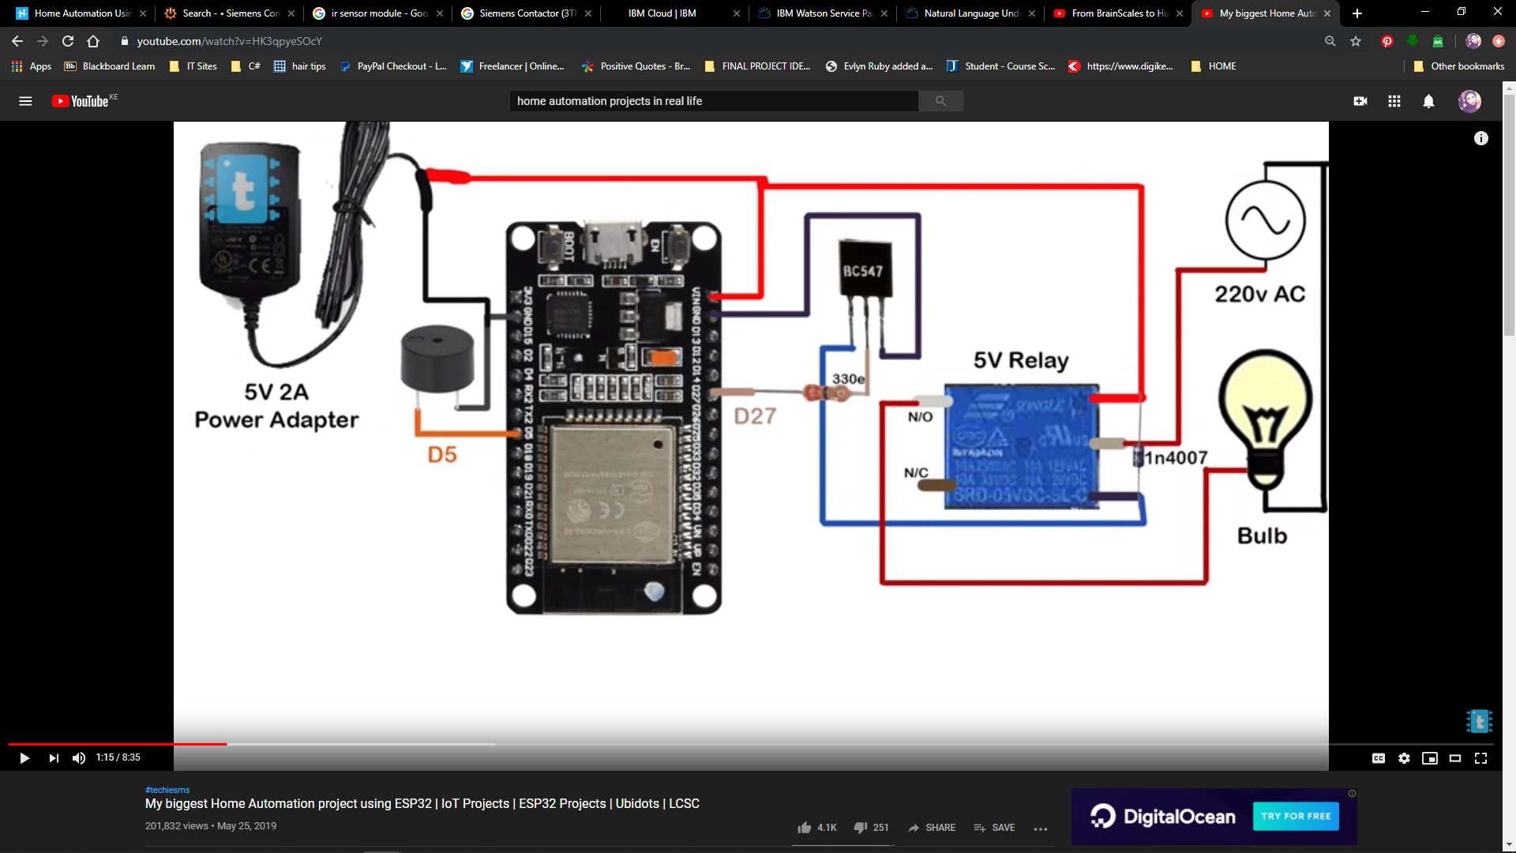PCB+SOLDERING

**PROTOTYPE TO REAL LIFE**

- read report and add stuff there

- plan to see it in real time

- check on how to make simple thing possible... start with bulbs, fans or anything in automation (AC, FAN DOOR)

- check the specific elments implemented

- check for volatage it needs

- check how to connect it home system (Arduino ESP32, raspberry etc)

-debugging issues

**COMMUNICATION SCHEME**

-arduino and rasp will connect via I2C Bus: (define protocols, I have defined protocol for sending and receiving bytes. Sending bytes are fixed of three while receiving byte array is of fourteen bytes.

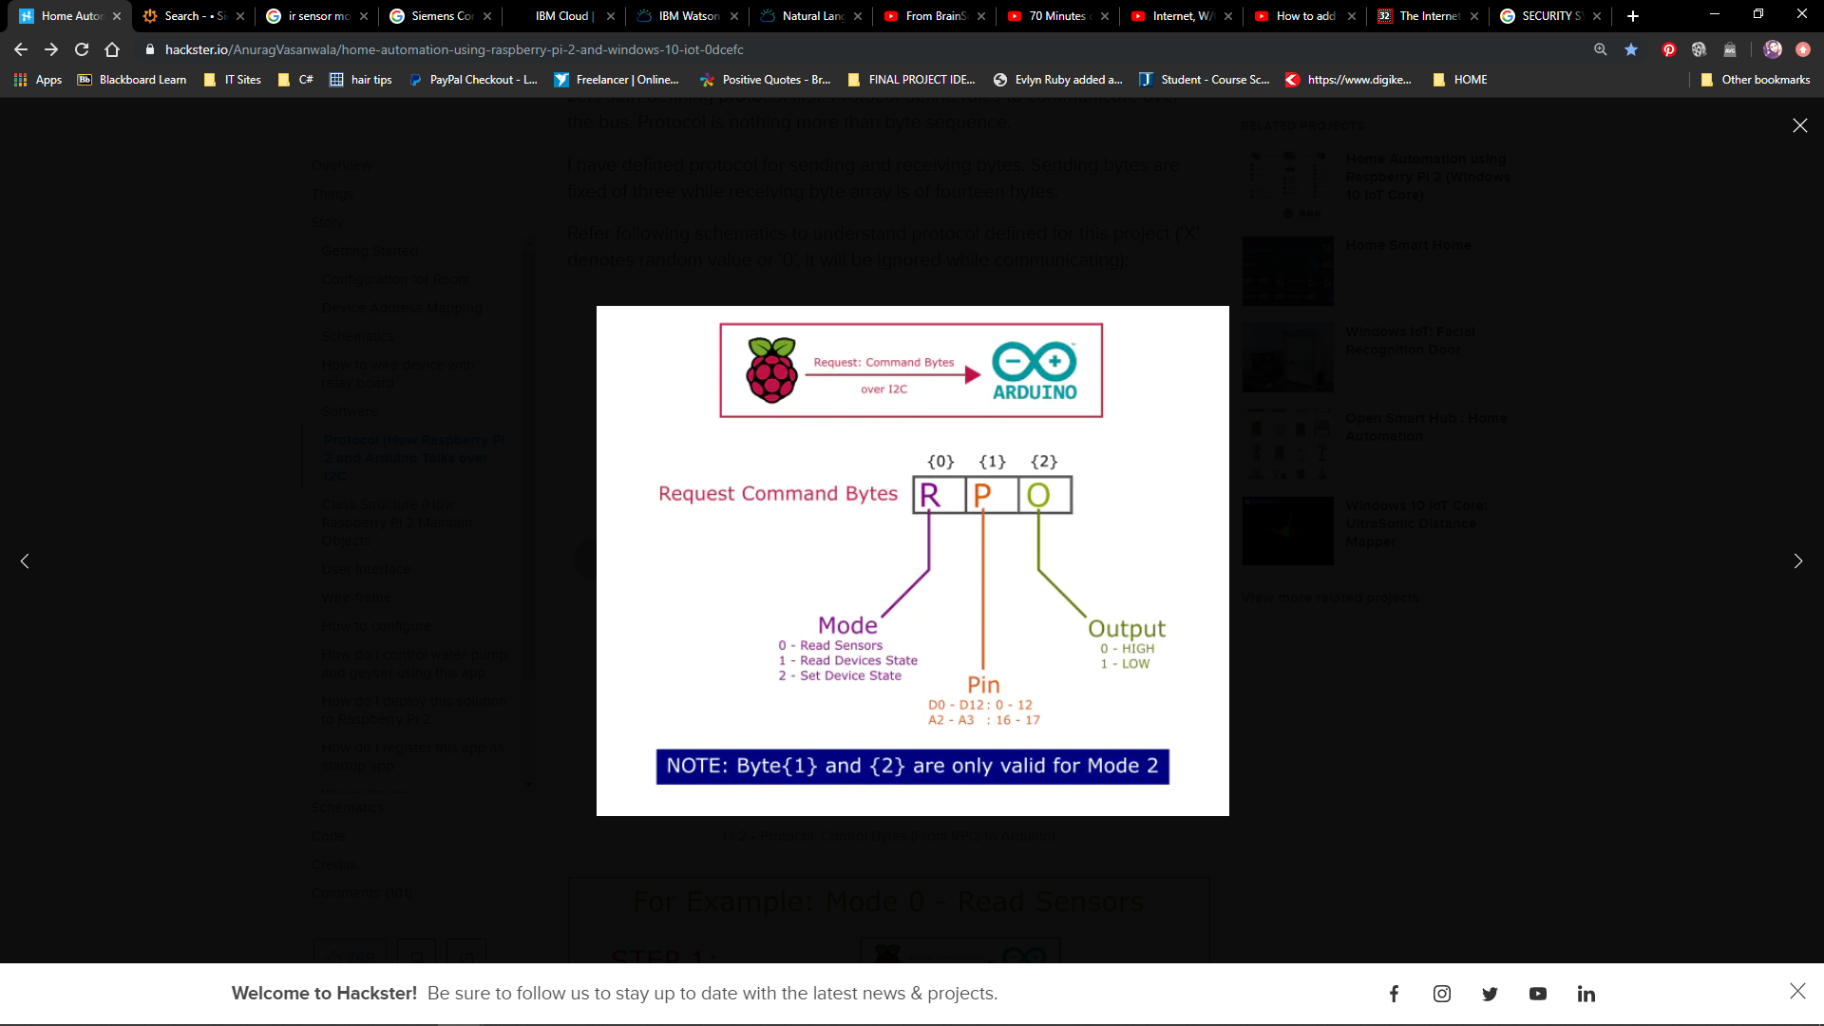

----------------------------------------------------------------------------------------------

HARDWARE

>LIGHTS - Pilips hue smart bulb

> AC - Nest/ecobee ; adjust ac or heating based on time of the day when u arrive home,

;visible temp

>FANS ; Humidity &temperature

SOFTWARE

> Google Assistant

>Microsoft Azure / cloud

> Firebase

>Visual studio 2015 for raspberry

>visual c#

>Windows universal XAML (UI Wireframe)

UI

how to integrate them in such way that they will be most easy to end-user.

In this application's scenario, our main objectives are:

* Room Management
* Device Management
* External Services like GSM Communication, Internet Communication, etc

To do so, I have splitted problem into:

* Home Page: Provides basic device status information, date-time and lock
* Favorite Devices: Direct access to favorite devices
* Room Page: Provides access to configured rooms and their devices
* Settings/Configuration: Provides management of rooms and their devices

SECURITY

>DOORBELLS & CAMERAS - facial recog , Motion detector, sends alert when u aren't home & saves recordings

> CAMERAS - Simplisafe for door sensors and indoor motion sensors

OTHERS

+ Sprinkler system - water automatically based on the weather

+ window shades that close with the touch of a button

+ robot vacuums that clean the house while you're gone

+ kitchen appliances you can operate remotely,

+ smart outlets that can control just about anything that plugs into a wall.

+ motion sensor from balcony notifies incase of invasion

NB: FIGURE OUT THE SECURITY SYSTEM

HOW FAR? AUTOMATION

- HEALTH

- SECURITY

- AGRICULTURE

- EDUCATION

- RESIDENTIAL

- INSURANCE